**Retrigger Port Assignment**

**Note added by**[**mq027t**](qto://talk/mq027t)**q_bulb on:  07/13/2017 08:40:31 for Ticket #: 000000233510781**

Application: USRP-FRAME/ATM

Problem: 1 TO 19 UNIQUE CUSTOMER ORDERS ARE UNABLE TO BE COMPLETED

RPT_SVC_LINE: AVPN

RPT_SUB_SVC_LINE: AVPN Mgd MOW Ethernet

ORG_GROUP_DDL: AVPN Dom Transport

LOCATION_ID: US

SERVICE_IMPACT: Yes

CNTRL_INTRO: Release

ORDER_NUM_FR_ATM: VR17125904

SALES_PARTIAL_ORDER_NUM:

USO_NUM: VR1712590

ICORE_SITE_ID: 2981358

CIRCUIT_ID: MMEC.842722..ATI

MCN_NUM: TA8874

GRC_NUM: SEP

SOC_NUM: TG

ICORE_PVC_ID: 130200

ADDRESS_VALIDATION_REQ_ID: CAEMET4225583-F

ADDITIONAL_ORDERS:

KEY_ITEM_AFFECTED: 1

PROB_CAT: OTHER ISSUE

PROB_DETAILS: Need load OCSSS/Sots buttons.Order not loaded in SOTS.

Sephora ISR17070423048-0001

VR17125904

31405620 / 3140FYFP

PROB_DESC: Need load OCSSS/Sots buttons.Order not loaded in SOTS.

Sephora ISR17070423048-0001

VR17125904

31405620 / 3140FYFP

UPLOAD: None

EMAIL_ADDRESS:

REF_TKT_NUM: 31405620

ORDER_TYPE: New

SUBMITTER_ATTUID: mq027t

- Alt Contact: mq027t

1. Check the order status in QSOTS

<http://usrp.web.att.com:8008/cgi-bin/query_so_status>

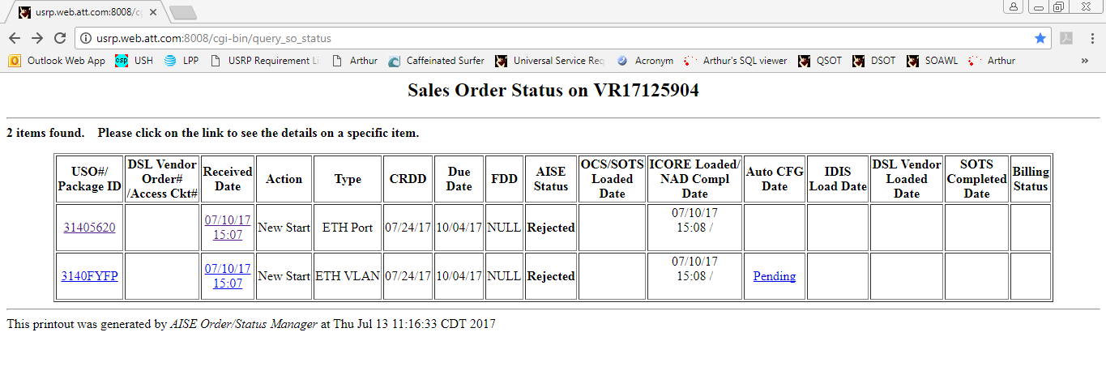

1. Check the load buttons in USO Worklist.

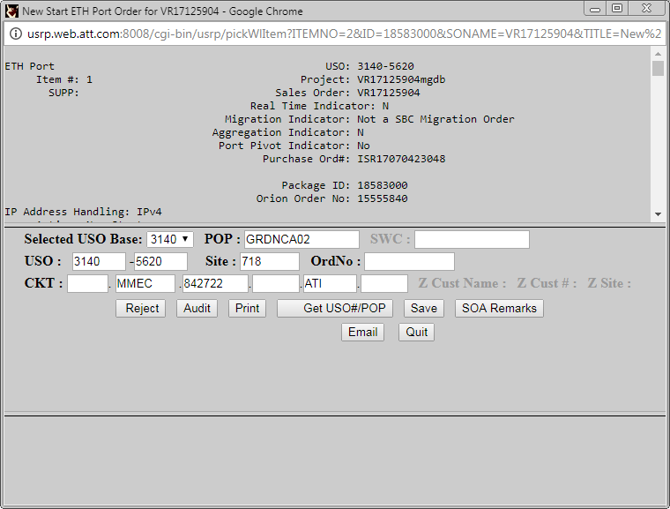

1. Check whether the order is loaded to ICORE.

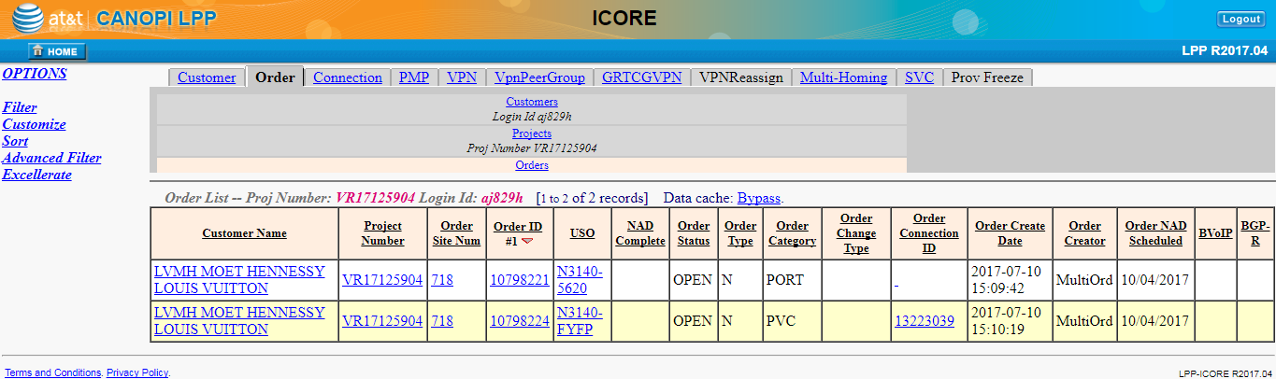

1. Check for candidate types in DSOTS.

<http://usrp.web.att.com:8008/cgi-bin/display_sales_order>

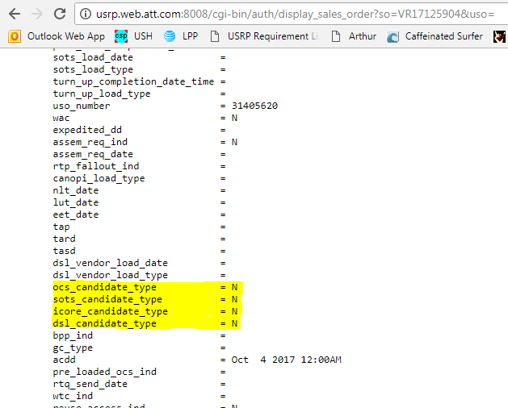

1. If the order is loaded to ICRE and candidate types are not set in USRP, then go to Project/Site in Project Detail Page (ICORE GUI)

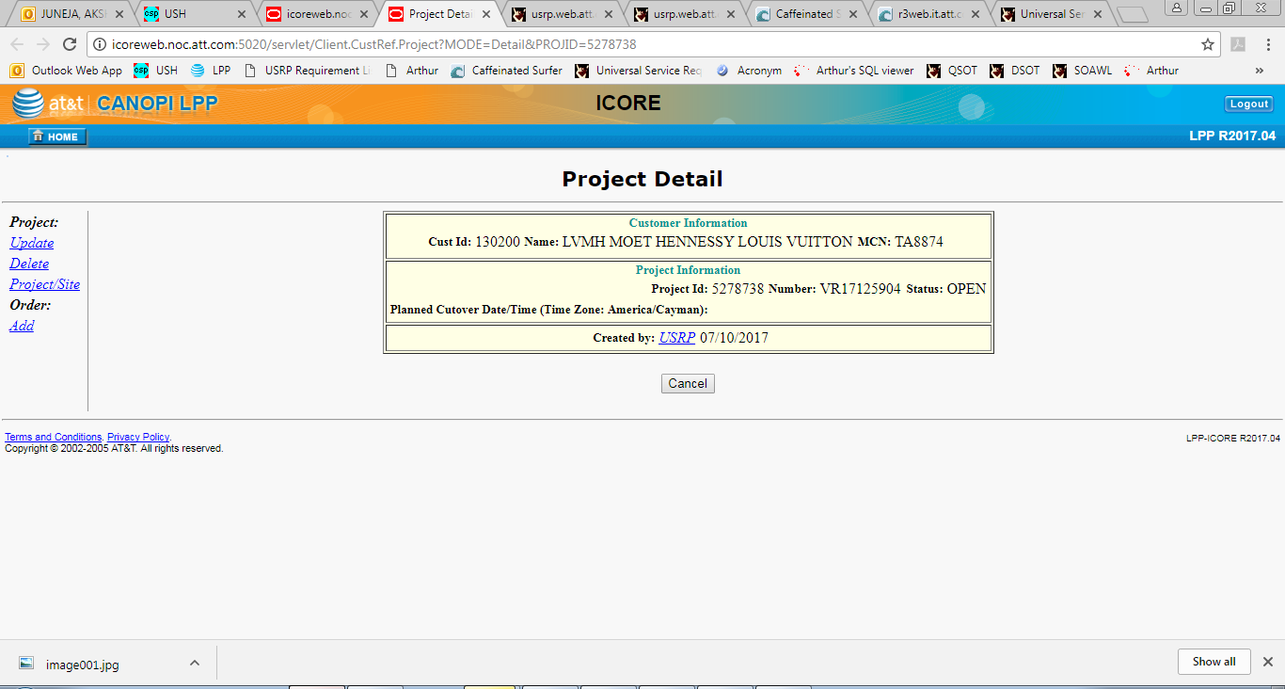

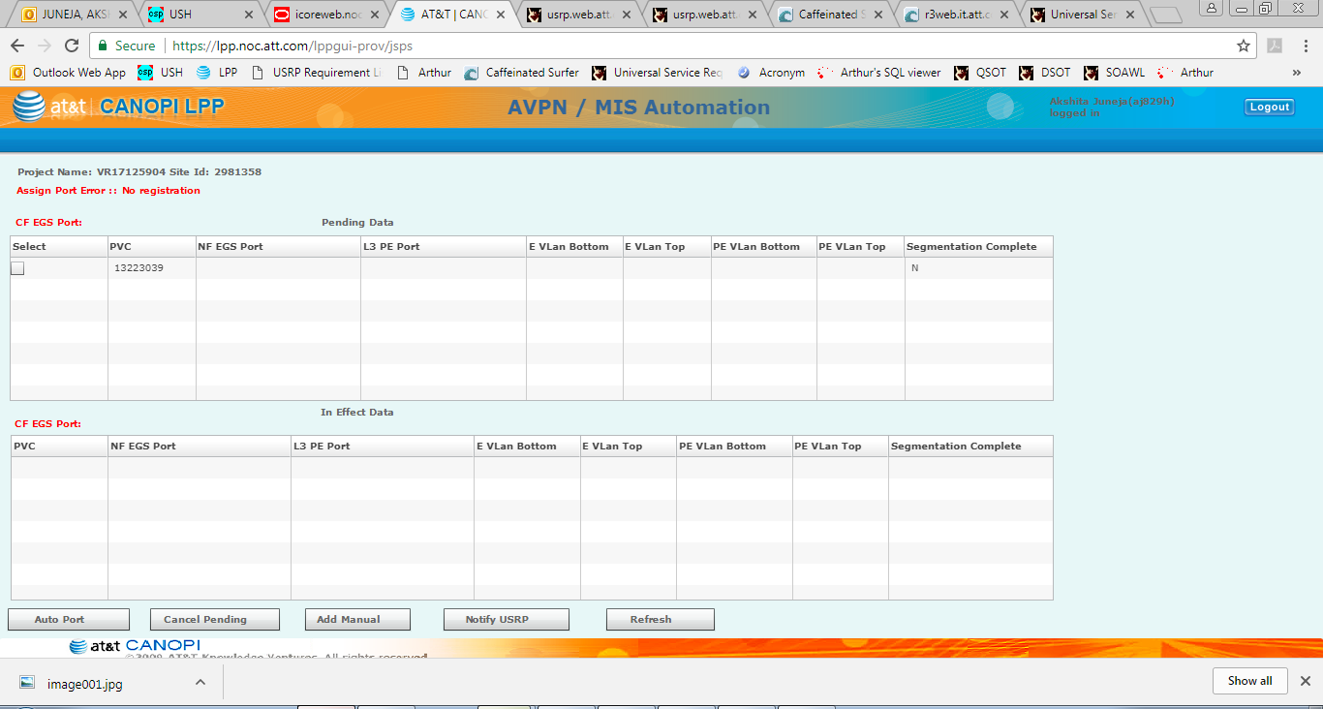

1. Click the check box if available and click on Auto-Port Button to auto assigned the ports.

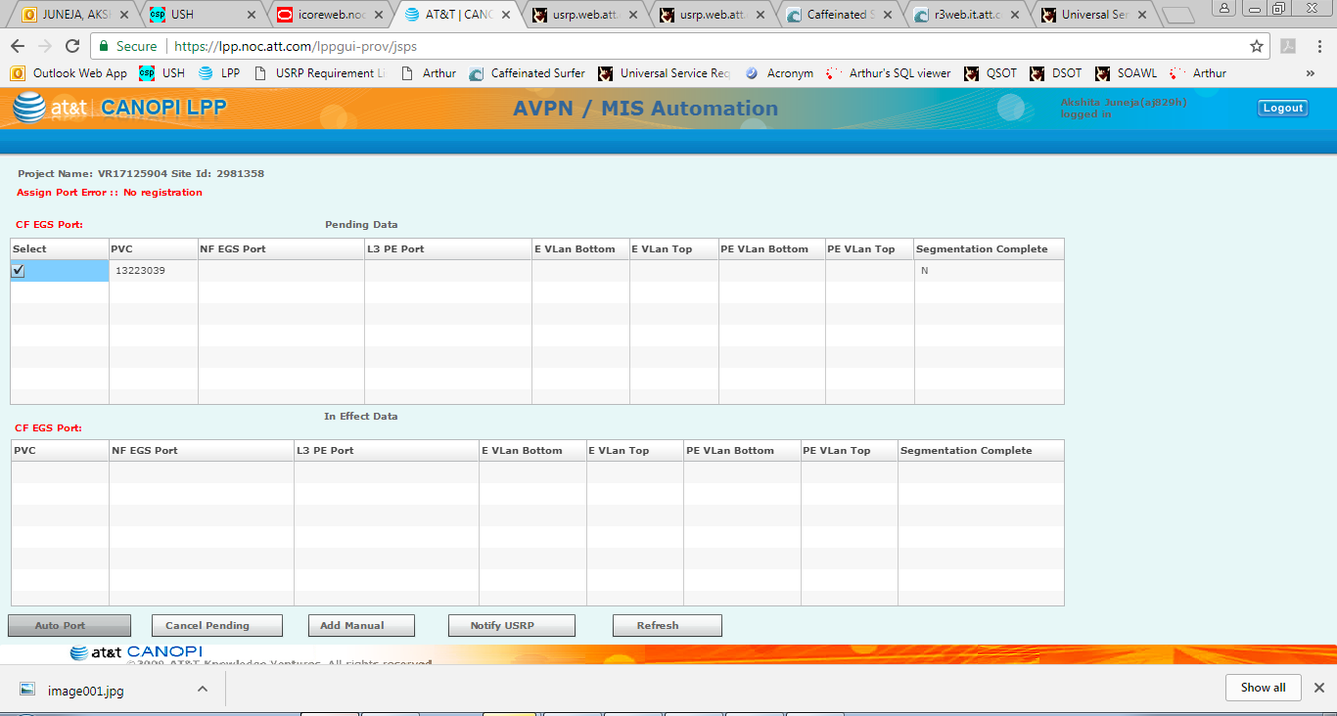

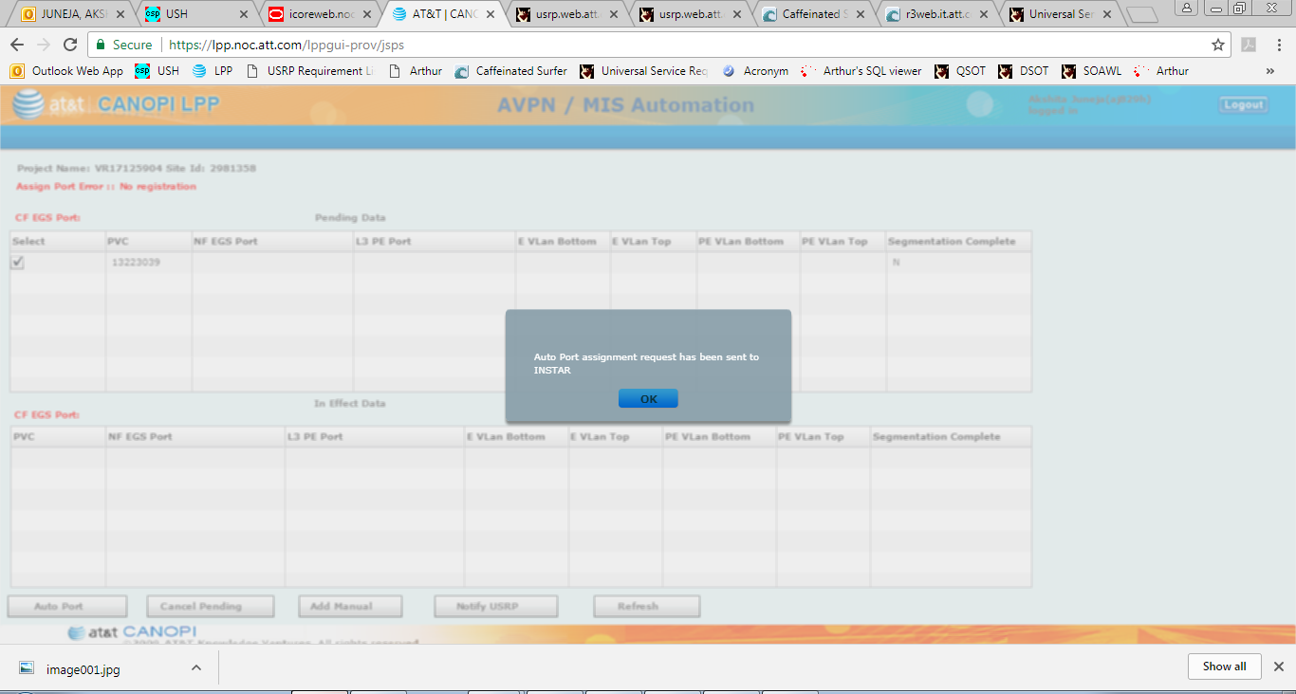

1. Wait for few minutes and the check for candidate types or the load buttons in WL.

